Balanced Scorecard Analysis for Ragland Department Store

Assumpta Osiri, Dhruv Lakhpatia, Kun Zhang
Ottawa University
Managerial Accounting BUS 7800
Dr. Eric Weedon
October 18, 2025

Case Overview
Ragland Department Store, according to the Retail Store Case Study, can use a balanced scorecard (BSC) to translate strategy into a concise, measurable system that aligns people, processes, and investments with recovery goals in a newly competitive retail market. The analysis explains why a BSC is useful, proposes a store-specific scorecard with operational definitions, and outlines what management should do if results are mixed after year one.
Introduction
In today’s competitive business environment, retail organizations must go beyond financial metrics to measure and manage their performance effectively. The Balanced Scorecard (BSC), introduced by Kaplan and Norton in the early 1990s, is a strategic planning and management system that allows organizations to align business activities with the vision and strategy of the organization, improve internal and external communications, and monitor organizational performance against strategic goals. According to Kaplan R. S. & Norton D. P. (1992) “The Balanced Scorecard Links Performance Measures: How do customers see us? (customer perspective), What must we excel at? (internal perspective), can we continue to improve and create value? (innovation and learning perspective), How do we look to shareholders? (financial perspective). Adopting a BSC is significant for retail companies as it provides a holistic view of the business, ensuring that performance is measured across multiple dimensions rather than focusing solely on financial outcomes. Research supports that organizations that implement the BSC approach experience improved strategic alignment, better performance tracking, and enhanced decision-making capabilities (Parmenter, 2020).
Significance of Adopting a Balanced Scorecard (BSC) for Ragland Department Store
A BSC matters for Ragland for four reasons. Firstly, in the concept of strategy translation and alignment. Specifically, this converts the store’s recovery thesis into objectives, measures, targets, and initiatives so daily work lines up with competitive positioning. Kaplan R. S. & Norton D. P. (1992) shared that “the scorecard brings together, in a single management report, many of the seemingly disparate elements of a company’s competitive agenda: becoming customer oriented, shortening response time, improving quality, emphasizing teamwork, reducing new product launch times, and managing for the long term”. Secondly, it will help Ragland in the balancing of lagging and leading indicators. It complements profit and margin with predictive levers like conversion, on-shelf availability, and staff capability. Thirdly, looking at the issue of causal logic via strategy maps, second-generation BSCs make explicit how learning & growth enables process excellence that raises customer outcomes and, ultimately, financials. Finally, looking at its contemporary relevance and lessons learned, systematic reviews show BSC’s continued utility when adapted to context and governed actively. According to Kumar, S. et al (2024) “Therefore, the BSC ---- can be viewed as a strategic management tool that (i) operationalizes strategy (vision, mission) into more specific and tangible forms for measurement and management, (ii) ensures that key (multidimensional) information, both financial and non- financial, are identified, monitored, and actioned upon, (iii) offers a balanced view of the organization, and (iv) provides a comprehensive yet succinct overview of strategic progress that complements detailed management (financial, operational) reports”.
Balanced Scorecard for Ragland Department store
As mentioned earlier, the BSC includes four perspectives: Financial, Customer, Internal Business Processes, and Learning & Growth. Below is a tailored BSC for Ragland with specific performance measures for each category:

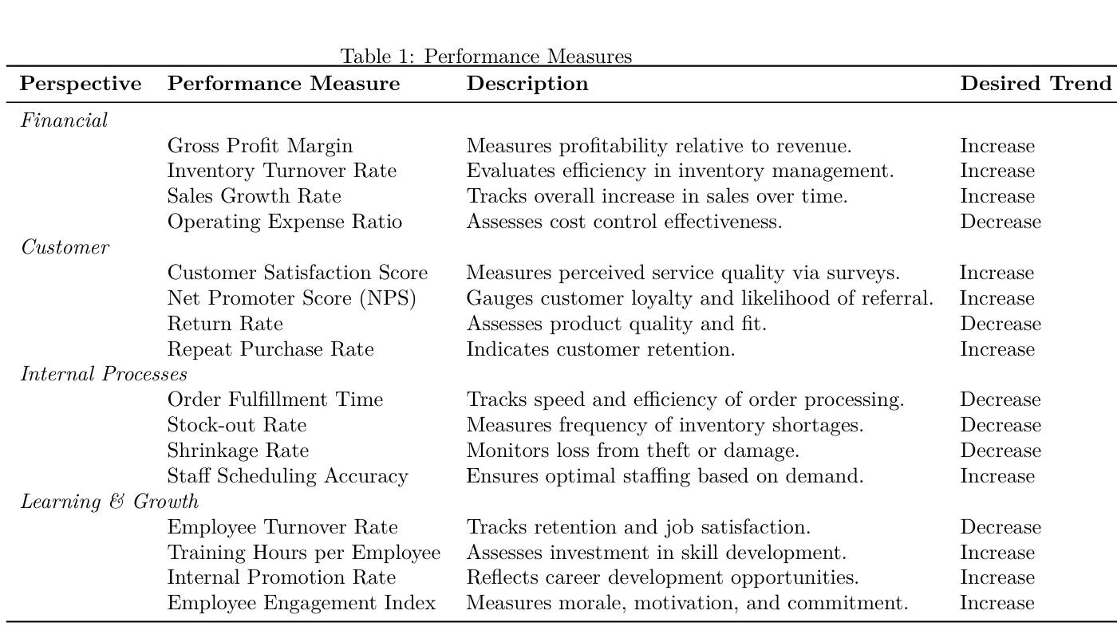
Performance Measures: Description and Strategic Benefit
Each performance measure plays a vital role in aligning Ragland toward strategic objectives. In terms of financial perspective, Gross Profit Margin indicates profitability and helps with pricing and sourcing decisions, Inventory Turnover ensures that inventory is moving efficiently without overstocking, Sales Growth Rate shows market expansion and brand effectiveness, and Operating Expense Ratio reflects operational efficiency and cost control.
From the Customer perspective, Customer Satisfaction is key to brand reputation and retention, NPS provides insight into customer loyalty and potential organic growth, Return Rate can reveal issues with product quality or fit and Repeat Purchase Rate is a strong indicator of customer lifetime value. Looking at the Internal Processes perspective, Order Fulfillment Time impacts customer satisfaction and operational efficiency, Stock-out Rate affects sales and customer trust, Shrinkage Rate helps in controlling theft and loss and Staff Scheduling Accuracy ensures labor optimization. And from the Learning & Growth perspective, Turnover Rate reflects organizational health and staff morale, Training Hours lead to improved employee capabilities and service, Promotion Rate encourages internal mobility and motivation and Engagement Index is predictive of productivity and service quality.

Performance Measures: Description and Strategic Benefit
After a year of operating with the BSC, suppose management finds that customer and financial measures have improved, but internal processes and learning & growth have stagnated or declined. Management might consider undertaking the following actions. 6. Firstly, diagnose root causes by conducting interviews and data reviews to identify process bottlenecks or morale issues. Secondly, invest in training by allocating resources toward employee development to improve capabilities and satisfaction. Next might be to refine internal KPIs to ensure they are realistic, measurable, and aligned with frontline operations. Next might be to enhance communication by bridging the gap between leadership vision and employee understanding. And lastly, iterate the scorecard by using feedback to update BSC metrics and targets regularly. Continuous monitoring and engagement with each perspective ensures that all components of the business evolve harmoniously.

References
Cloudflare, Inc. (2025). What is Anycast? How does Anycast work? Retrieved from https://www.cloudflare.com/learning/cdn/glossary/anycast-network/
Internet Assigned Numbers Authority. (2025). Domain Name Services. Retrieved November 8, 2025, https://www.iana.org/domains
Internet Assigned Numbers Authority. (2025). Root Servers. Retrieved November 8, 2025, https://www.iana.org/domains/root/servers
Root Servers Organization. (2025). Root Server Information. Retrieved November 8, 2025, https://root-servers.org/

